**Is Jessica Simpson Pregnant or Plain Boozing?**



Jessica Ann Simpson has been in the entertainment industry since the age of 16. She is an American and one of the most prolific singers in the US. She is also an actress and fashion designer, born July 10, 1980. She came into the limelight in 1999 with the release of her first album. The album sold over four million copies across the globe, and one of the tracks in it "I Wanna Love You Forever" hit the top 3 mark in the chart.

She followed this up in 2001 with another hit album *Irresistible* which made it to the top twenty mark on the BillboardHot 100 with its title track. The album also won a gold certification from the Recording Industry Association of America (RIAA). She is best known for her third studio album, *In This Skin* (2003) which sold over seven million copies worldwide. One of the tracks in the album, *With You* (2003) reached the top of the Mainstream Top 40 chart. She is also well known for her Jessica Simpson Collection, a line of fashion that has sold over $1 billion worth of fashionable materials since she established it in 2005. She continues to produce more studio albums and fashionable materials, she has also starred and continues to act in films and reality television series such as *The* *Price of Beauty* (2010).

However with all the successes in her career, one would have thought that she’s got it made. The average person will be surprised at the controversies and scandals in her private life that appear on the most part to be self-inflicted. Her first marriage in 2002 failed even though it boosted her career and made her and her husband a household name. Her husband, Nick Lachey was another ace singer and together they starred in a reality TV show that followed their marriage and respective careers. Soon they would become a pop culture phenomenon and achieve high ratings success for MTV. However, irreconcilable differences between the couple soon emerged and by November 2005, the marriage was over.

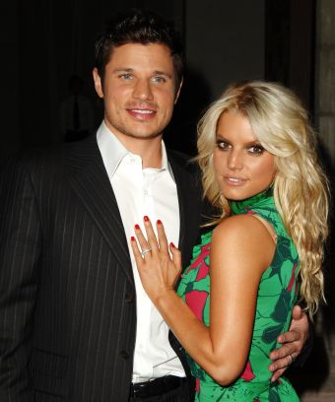

**Jessica with Nick Lachey**

So what went wrong? For a start, it is possible that Jessica did not make a wise choice of spouse. According to Sue Kolinsky, the producer of *Newlyweds*, he couple were too different. Nick was 7 years older than Jessica. Kolinsky, in an interview with *Complex* noted "He was frugal, and she had excessive taste. In the end they weren't suited for each other. The only thing they really had in common was their music. She was really young; I think he's seven years older than her. He wanted a family, and her father [Joe Simpson] thought maybe she was too young. Her father was very involved in her life."



Then there was the aspect of Jessica cheating in her marriage with Nick and using her acting skills to portray herself as the victim of a greedy husband. Rumors began flying around that Nick was sleeping around with other men. One of the men in question, the star of *Jackass*, Bam Margera, revealed that he had sex with Jessica while filming the *Dukes of Hazzard.* In an interview with Howard Stern he stated that they "wound up at her parent's house drinking margaritas and it went from there."

It is now 13 years since she divorced Nick but she doesn’t seem to have learnt much about keeping a marriage. She is busy boozing and partying rather than trying to keep her latest marriage and be a role model to her two children, Maxwell 6 and Ace 5. She is now married to Eric Johnson, a former retired NFL star. Her fans are getting really worried that Jessica Simpson may blow her career and family.

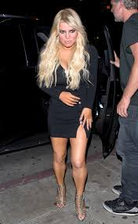

Her close friends and associate are making excuses for her saying that she is using alcohol and similar substances as coping mechanism because she has been having a rough time lately. The pressure of work and her father battling cancer may be proving too tough for her. One of her closest friends, in an interview with i*nTouch* retorted "Jessica is reviving her music career, her fashion empire continues to thrive, she has a husband who loves her and two of the cutest children in Hollywood, but she's blowing it all due to her self-doubt and drug and alcohol issues".

In 2015, she had to go into rehab for alcohol abuse after her husband, Eric put his foot down. He was worried the wife’s behavior was going to affect the growing children. The elder child was already asking questions what is wrong with mommy.

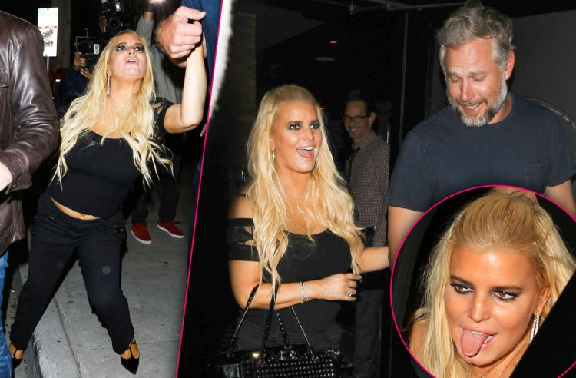

In April, 2018 she was seen apparently drunk leaving Craig restaurant holding on to her husband and falling down the stairs. Some close associates say she mixes alcohol with Adderall pills.

However, Jessica seems to have her own plan to address the issue. She is reported to be longing for another child as an additional coping mechanism. She has publicly revealed that she believes another Child is what she needs to solve their problem. So when she was spotted last week in New York City wearing a mini silk dress that exposed a big tommy it was to be expected that rumors would start flying around that she is pregnant.



The rumors intensified when she appeared at the Outstanding Mother Awards at The Pierre Hotel in New York City on May 13 with her mother and her husband. She usually flashes her figure but this time she wore a yellow dress that concealed her figure when she gave a speech to a VIP audience that included the former President of the US, Bill Clinton.

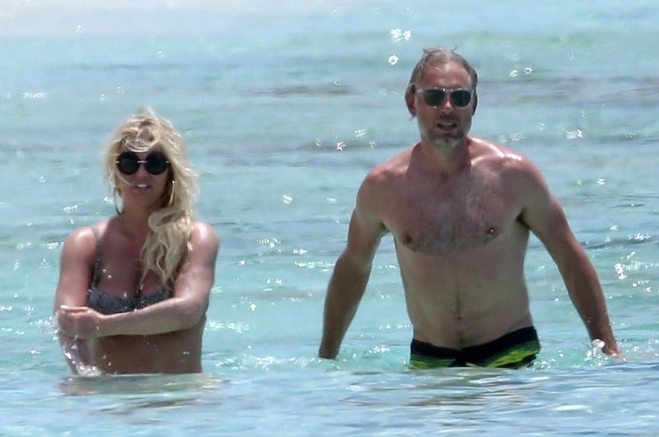

Prior to that she had along vacation in the Bahamas with her husband, in which she appeared in a bikini that exposed a figure that can be associated with a pregnant woman.



Back in the US, her fans are unanimous that what she needs is a wakeup call from boozing rather than a third child.